Searched with 01-09-2020 to 02-09-2020, but only 01-09-2020 entries showing. 02-09-2020 entries are not coming.

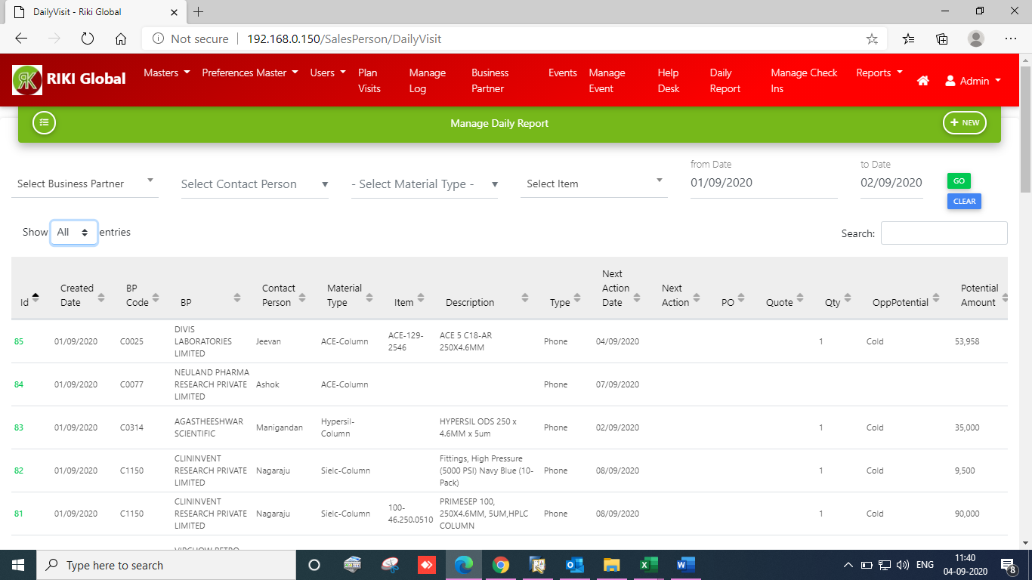

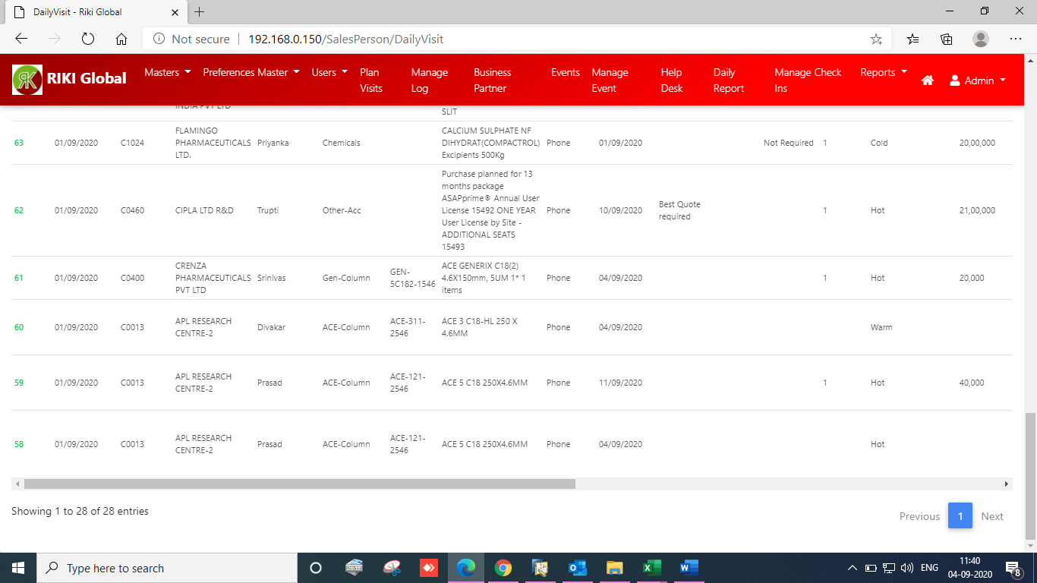

Please see the below screen shot, date search is 01-09-2020 to 03-09-2020, but only 01-09-2020 & 02-09-2020 data is showing and 03-09-2020 data is not coming

